**CTF Topic: Operating Systems**



**Introduction**

Operating systems (OS) are essential software that manage computer hardware and software resources and provide common services for computer programs. Common operating systems include Windows, macOS, Linux, and Unix. Understanding the basics of operating systems, their components, and functions is crucial for anyone studying computer science or working in IT.

**Tools and Requirements**

Web resources for learning about operating systems

[<https://www.geeksforgeeks.org/what-is-an-operating-system/>

**Scenario**



As a beginner in computer science, your task is to answer questions related to different operating systems. This will help you understand the fundamental concepts and features of various operating systems.

**Process to follow while performing CTF**

To begin, use online resources to familiarise yourself with different operating systems and their features. Answer the following questions based on your understanding.

**Questions**

Flag 1: What is the name of the operating system developed by Microsoft?

Answer: Windows

Flag Captured.

Flag 2: Which operating system is known for its graphical user interface and is developed by Apple Inc.?

Answer: macOS

Flag Captured.

Flag 3: What is the name of the open-source operating system kernel developed by Linus Torvalds?

Answer: Linux

Flag Captured.

Flag 4: What command is used to list files in a directory in Linux?

Answer: ls

Flag Captured.

**Hint**

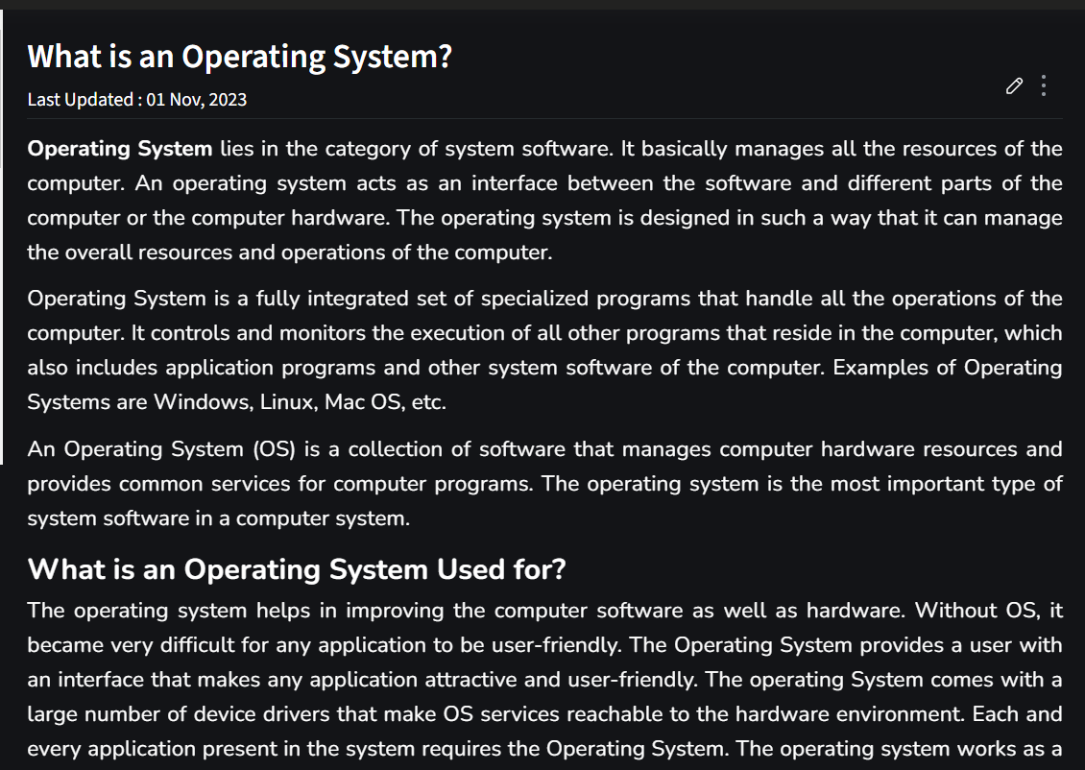

Use reliable web resources to look up definitions and examples of different operating systems. Focus on understanding the key characteristics and functionalities of each operating system.